**CrackDown User Manual**

**What is CrackDown?**

CrackDown is mobile application platform. It can be used to share your answers with your friends during your online exam.

**How it works?**

Traditionally you share your answers on WhatsApp or similar platform. But if your group has big number of images then it will be very difficult and time-consuming process to find your questions answer among all the collected images on group.

Now, here comes CrackDown, it will match your question with all the images you have and will give matching answers among all images within a second!

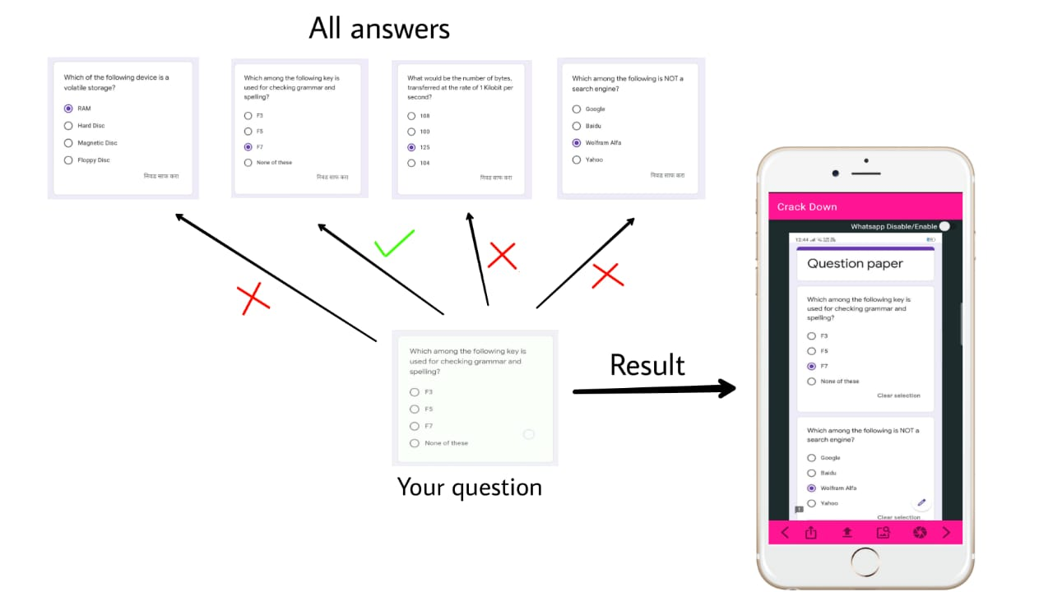

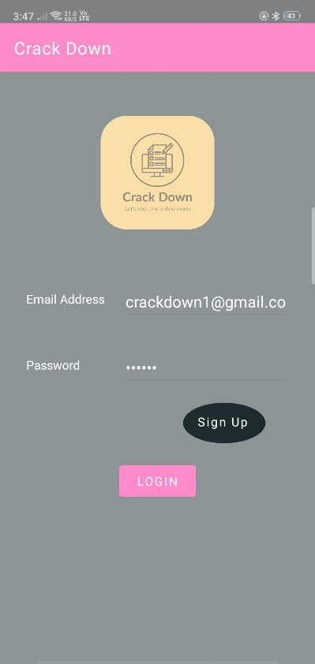**How to use it?**

**Signup:**

Create your new CrackDown account.

Fill the necessary details and signup.

Use Emai and Password to Login.

In CrackDown there are two ways to share your answers with your friends.

1. **Share answers on WhatsApp or similar platform and collect that answer images from CrackDown by giving appropriate path of image folder.**

**Manual Path (to collect images from given location):**

Give the manual path to collect images from that folder.

Eg. Here WhatsApp path is given which means collect answer images shared by your friends on WhatsApp.

Similarly, you can give any path like, **/storage/emulated/0/Telegram/Telegram Images**

to collect images from telegram.

**-**

* Graphical user interface, application, website

  Description automatically generated**Use WhatsApp Only Mode:**

WhatsApp Only Mode can be used when you

Want to share your answers only on whatsapp.

In this case you do not need to create Group

to use CrackDown.

You can only collect answers from WhatsApp

match your image with collected images.

**Switch:**

If you want to collect images from WhatsApp/Telegram like similar platforms then Enable the switch otherwise Disable the Switch.

* **Last Time(in min):** Used to collect previous images.

If you are collecting images from WhatsApp and while

using CrackDown if your app gets removed from

background or you closed it for some reason then

you will lose previously collected images.

To overcome this situation, next time when you open

CrackDown you can give Last Time to collect previous

Images.

Eg**. Last Time(in min): 60** means start collecting images

from given path and also collect previous 1hr(60 min)

images from same path.

1. **Second way to share your answers is by creating CrackDown Group.**

CrackDown Group is same as your WhatsApp group where you and you friends share answers during online exam.

**Use CrackDown Group:**

* 1. **Create Group:**

Click on Create Group button.

You will get you Group Id.

Share this Group Id with your friends so that

they will join your group using this Group Id.

You and your friends will be connected

Under same Group Id.

**\*\*\*\*\*\*\*\*\*\*\*\*\*\*\*\*\*\*\*\* FUNCTIONALITIES \*\*\*\*\*\*\*\*\*\*\*\*\*\*\*\*\*\*\*\***

**Share Images Using Camera:**

Share your answers to other friends.

Click on the given icon, Camera will open, capture your answer image and press OK.

Your answer will be shared to all your friends who are connected under **same Group Id.**

As soon as you share your answer it will be collected by all your friends.

* 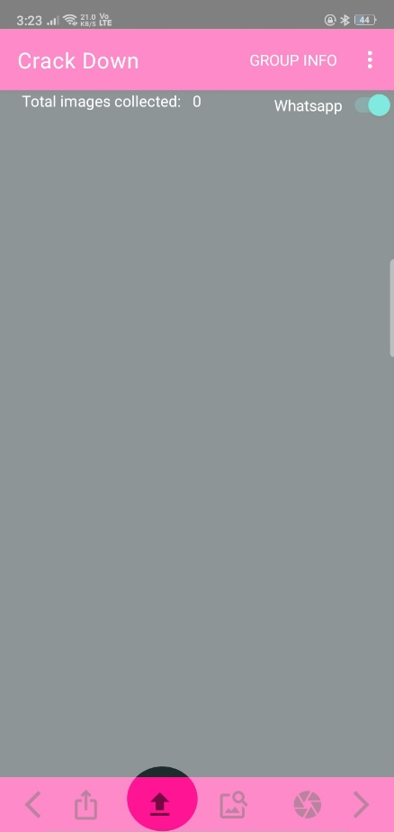**Share Images From Storage:**

If you want to share screenshot of your answers

with your friends use this option.

Click on given Icon, gallery will open, select appropriate

image and click OK, your answer will be delivered to

all your friends who are connected within **same**

**Group Id.**

**Find Answer Using Camera:**

Click on the given Icon, camera will open.

Take photo of your question, Click OK.

You question will be matched with all the collected answer images from your friends and the best matching image will be shown to you.

Use **<** and **>** for navigation.

* **Find Answer Using Screenshot of Question:**

If you have taken screenshot of your question and

you want to search this screenshot question among all

the collected answers then,

Click on the given Icon, Gallery will be opened.

Select appropriate screenshot of your question,

Best matching result will be shown to you.

**Group Info:**

Click on the Group Info button to see information about your group.

It includes Admin name and the members of your group.

This information will be used to check if any unknown member has joined your group.

**Some tips to increase efficiency of CrackDown.**

1. If you are using WhatsApp/Telegram to share your answer images, then **Enable Auto Download** feature so that you do not need to download images each time. Images will be downloaded automatically in background.
2. While searching your question using Camera try to capture image of only question, do not capture whole screen.
3. Use CrackDown Group instead of WhatsApp to know who is sender of the answer so that you can decide how much you should trust on that answer.

* **YouTube links for further reference:**
  1. Introduction to CrackDown: <https://youtu.be/L0OX4Yg_baQ>
  2. CrackDown Demo: <https://youtu.be/_qpdYuFu1lc>